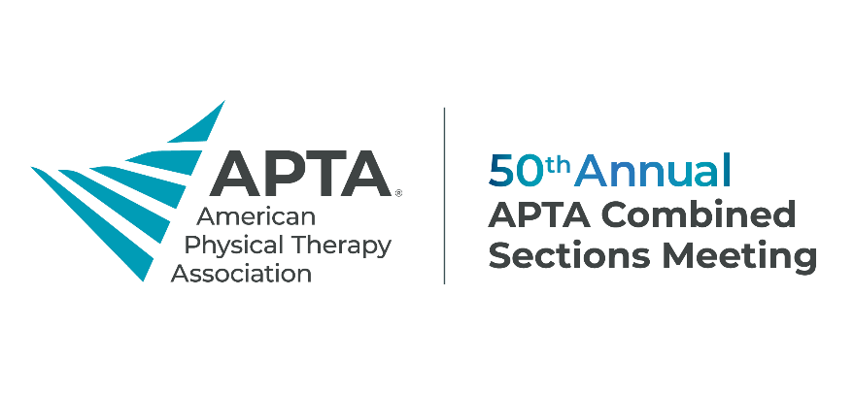
[Date]
Dear [Supervisor’s Name],
I would like to request approval to attend the APTA Combined Sections Meeting, scheduled for Feb. 12-15, 2025, in Houston, Texas. APTA CSM is the largest meeting for physical therapy professionals, offering unparalleled opportunities to engage with peers, learn from industry leaders, and explore cutting-edge research, tools, and practices.
This year's theme, "Mission to Excellence: Expanding Horizons in Physical Therapy," highlights APTA’s commitment to advancing the profession through innovative education, integration of new technologies, and professional growth. Attending this meeting will allow me to gain new insights and knowledge that directly align with our organization's goals.
By attending, I plan to achieve the following objectives:
- [Objective 1: Example — I will bring back new strategies to improve patient care in our practice area of [X].]
- [Objective 2: Example — I will network with professionals and identify potential collaboration opportunities.]
- [Objective 3: Example — I will attend sessions that focus on [specific interest area] and explore emerging trends that could benefit our team.]

The meeting includes over 400 educational sessions, covering a wide array of practice settings and specialties, ensuring that I will return with valuable, actionable insights to enhance our work. Additionally, I can earn CEUs through accredited courses.
The estimated breakdown of the costs to attend is as follows:
- Airfare: <$XXX>
- Ground transportation: <$XXX>
- Hotel: <$XXX>
- Meals: <$XXX>
- Early bird registration (available until Nov. 6): <$XXX> (APTA members receive discounted rates.)

The total estimated cost for me to attend APTA CSM is <$XXX>. I believe the professional development, networking, and education I would gain at this event will significantly benefit our organization and contribute to our long-term goals.
I would be happy to discuss this further and review the sessions that would be most beneficial to our work.
Sincerely,
[Your Name]

